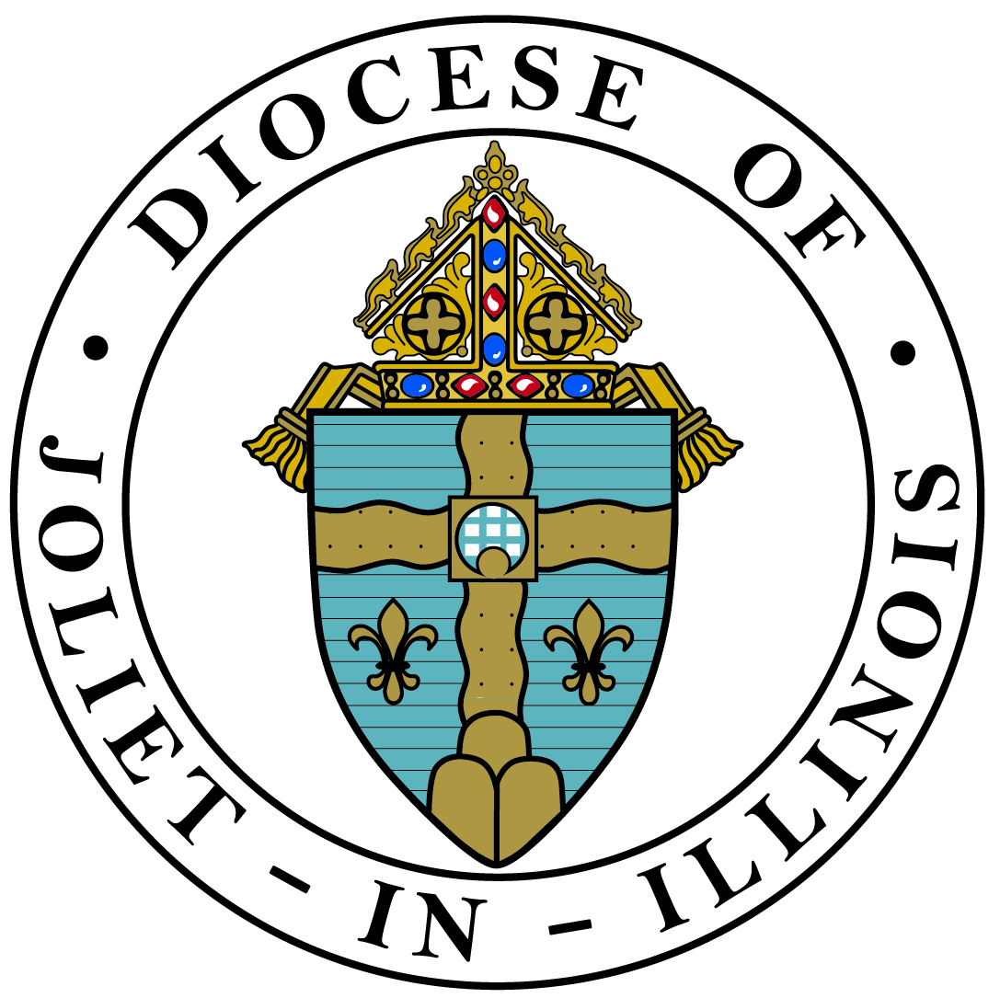
PARISH CATECHIST
ANNUAL FORMATION LOG
(When filling out electronically, tab to go to next field)

As a Catechist at (Parish Name), (Town)
I, (Catechist Name) understand that I am expected to participate in at least six hours of catechist formation every year.
During the academic year I have met or exceeded this requirement by participating in the following catechist formation and submitting my record of formation form for each formation experience.

Date Formation Event/Experience Hours

Annual Total in Hours

_____________________________ ____________________________ __________
Catechist Signature Parish Catechetical Leader Signature Date

NOTE: Please fill out a Catechist Record of Formation form for each event/experience of formation and be sure that this annual log is noted and maintained, either by the parish or yourself (as catechist), according to the established parish process. Events and experiences that further one’s competencies theologically, spiritually/personally and methodologically may be considered for inclusion. Consult your parish catechetical leader with questions about this. (Time committed to teaching or practicing Catholic faith is NOT eligible for inclusion.) The parish is to retain all related formation paperwork. It is a good practice for catechists to also keep a set for their own personal record.

